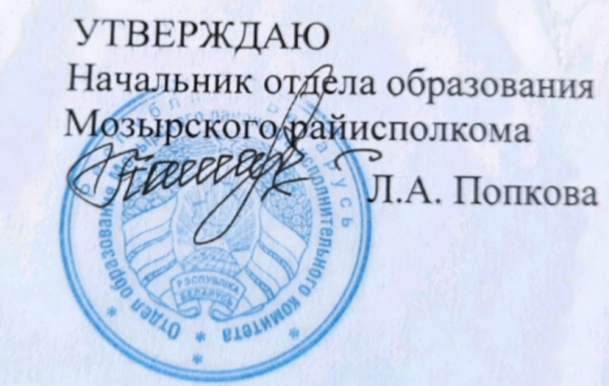
Задания первого этапа республиканской олимпиады
по английскому языку
2021/2022 учебный год
XI класс

Communicative skills assessment

1. How would you describe an ideal family?

2. There is no place like home. Do you agree?

3. Describe your life in five years from now.

4. Speak about friendship in your life.

5. Speak about the role of hobbies in people’s life.

6. Belarus is the country to be proud of.

7. Life without planning is inefficient. Do you agree?

8. Describe the house or the flat where you live.

9. Do you agree that the 20th and the 21st centuries are the centuries of new ideas and technology?

10. What would you do with a penny fall?

11. Hardships in life only make us stronger.

12. Describe a book that produced a great impression on you.

13. Speak about your favourite form of art.

14. Speak about the importance of a healthy lifestyle.

15. Speak about the changes which you would introduce in your school if you were a director.

16. Speak about your future career.

17. Speak about your idea of a perfect holiday.

18. Speak about the ecological situation in Belarus.
19. Doing shopping is a relaxing pastime.

20. Speak about activities you like doing together with other people.

21. Speak about the place you would like to visit in Britain.

22. You have a task to create a website. What website will it be and why?

23. Talk about mass media: TV, newspapers, radio. Which of these does your family prefer?

24. Speak about the role of education in modern life.

25. Learning a foreign language is an everlasting process.

